**ADT Lab 3 (10pts)**

**Q1 Executed all 4 Queries from Practical SQL Book/GitHub Link**

**Q2 Created count_hospitals_in_city View**

**Q3 Created materialized view mat_count_hospitals_in_city**

**Highlight the questions you are done with to green colour before you submit**

Instructions-

1. Install Postgres for Windows- <https://www.guru99.com/download-install-postgresql.html>

Install Postgres for Mac- <https://adamtheautomator.com/install-postgresql-on-mac/>

Create a new Database and give the name as your IU username

(Right click on the Databases on the browser pane, click on create, click on database)

1. See Chapter 3 from Practical SQL book

Book available from IU Library (with IU Login) - [Link](https://proxyiub.uits.iu.edu/login?url=https://search.ebscohost.com/login.aspx?direct=true&db=nlebk&AN=1515907&site=eds-live&scope=site)

GitHub Link for Chapter 3 SQL queries from book: [Link](https://github.com/anthonydb/practical-sql/blob/main/Chapter_03/Chapter_03.sql)

Reference for MySQL Datatypes:

Link: <https://www.w3schools.com/sql/sql_datatypes.asp>

Read Chapter 3 from start until Listing 3-4: The timestamps and interval types in action

1. Execute queries from the book/ GitHub link provided above up until Listing 3-4: Timestamp and interval types in action. Similar to the last lab post the screenshot below.  
     
   Sample screenshot:

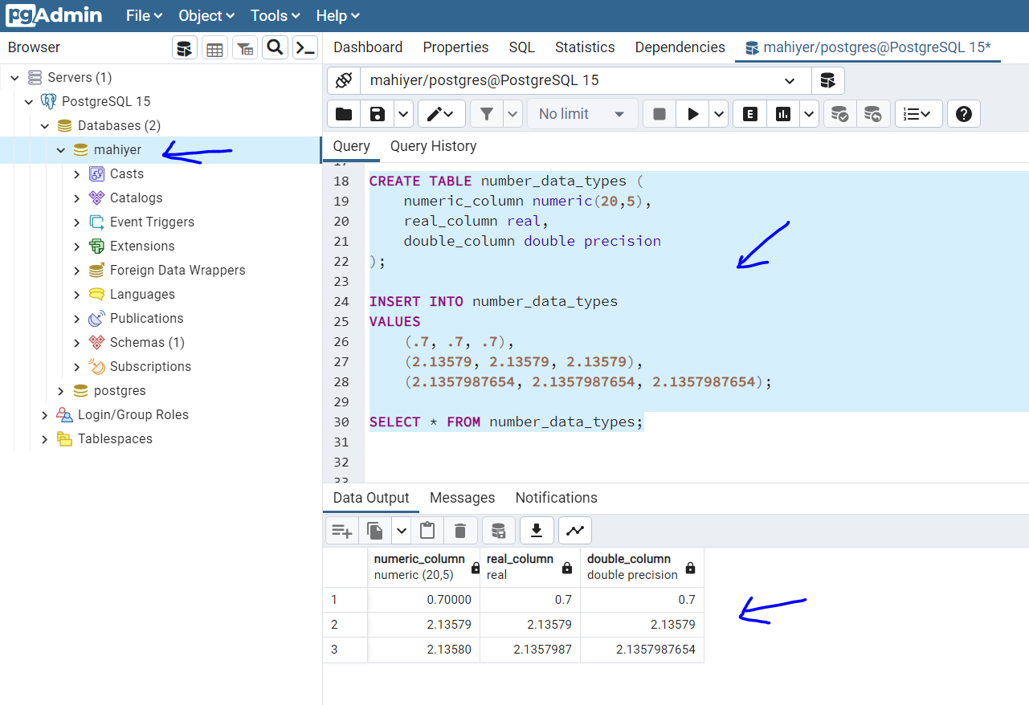

Listing 3-1: Character data types in action  
  
If you ae getting permission denied error while writing the file kindly refer- <https://www.neilwithdata.com/copy-permission-denied>   
  
# Screenshot

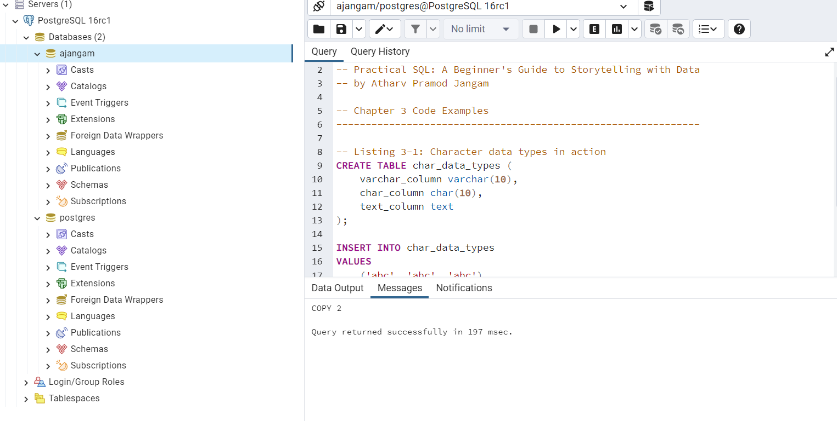

Listing 3-2: Number data types in action  
# Screenshot

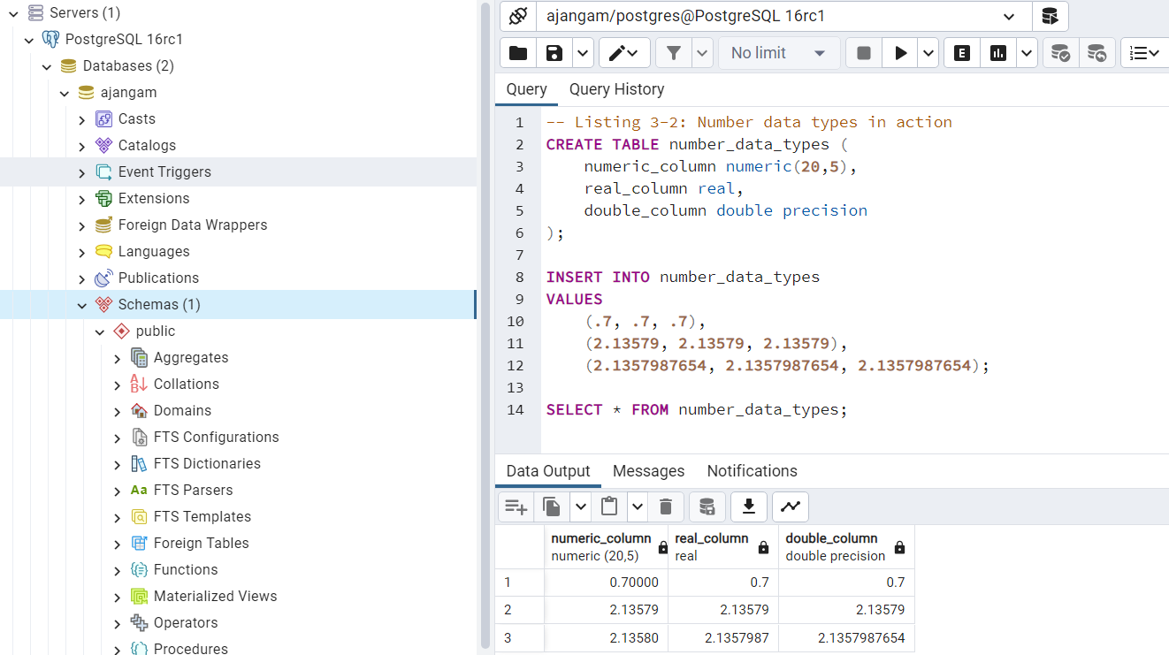

Listing 3-3: Rounding issues with float columns

# Screenshot

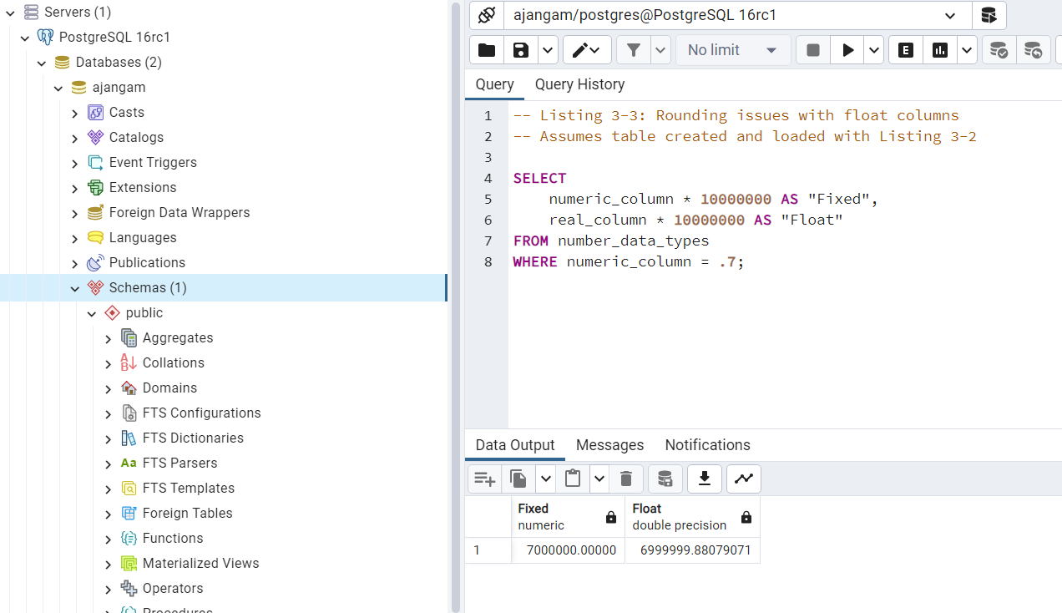

Listing 3-4: Timestamp and interval types in action  
# Screenshot

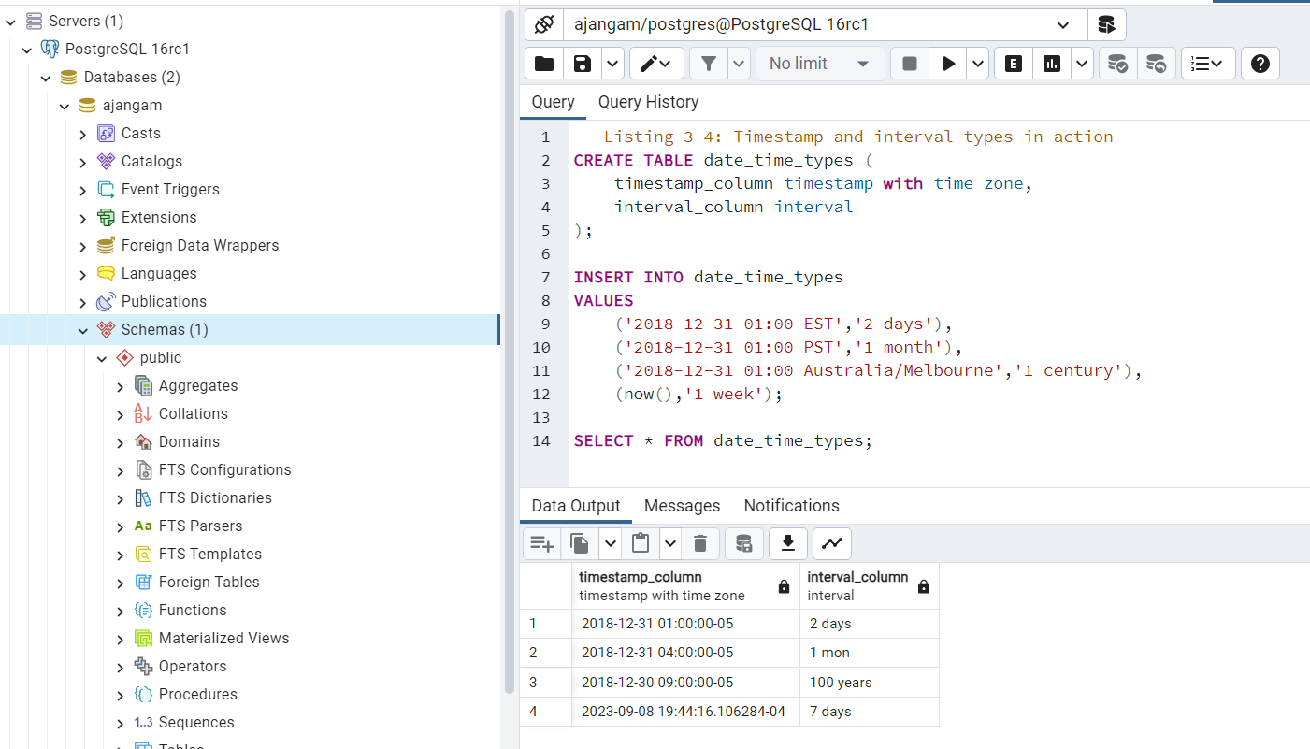

1. Read about what is a materialized view in PostgreSQL and Difference between Postgres view and materialized view from - <https://blog.devart.com/postgresql-materialized-views.html#difference>   
     
   Run the script doctors_db.sql from the Lab 3 files to create a doctors and a hospitals table  
     
   Create a view to count the number of hospitals in each city from the hospitals table by using the query-  
     
   CREATE VIEW count_hospitals_in_city AS

SELECT city,count(*) as hospital_count

FROM hospitals

group by city;  
  
Under the Schema dropdown, check under views dropdown on the browser pane if your view is created and paste the screenshot below.

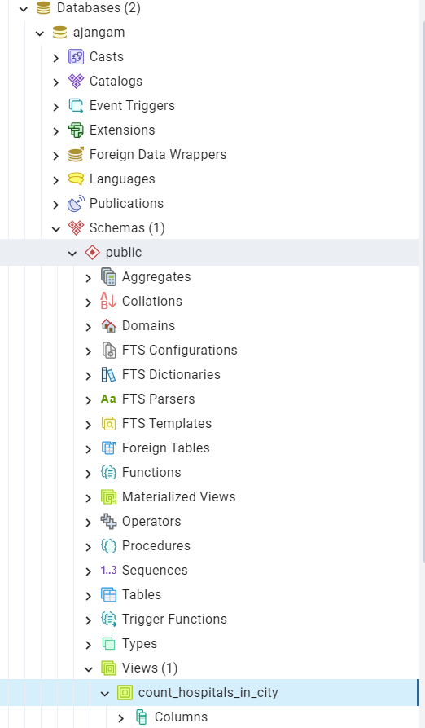

Example  
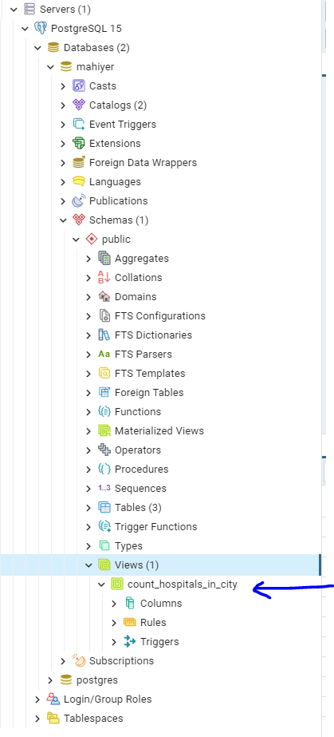

1. Create a martialized view by using the query-

CREATE MATERIALIZED VIEW mat_count_hospitals_in_city AS

SELECT city,count(*) as hospital_count

FROM hospitals

group by city;

Under the schema dropdown, check for your newly created materialized view and post a screenshot of it-

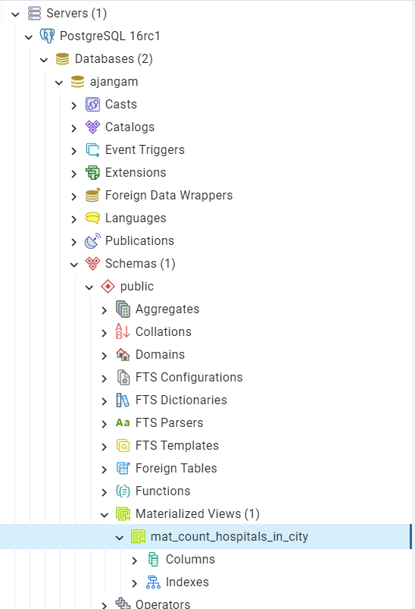  
  
Example-  
